**AI-Enhanced Personalized Learning Pathways**

**Revolutionizing Education Through Generative Models**

Ms. Punidha A,

Assistant Professor, Department of Artificial Intelligence and Data Science,

KPR Institute of Engineering and Technology,

Coimbatore, India.

**punidha.a@kpriet.ac.in**

Mr. Suriya Kumar V,

Student, Department of Artificial Intelligence and Data Science

KPR Institute of Engineering and Technology,

Coimbatore, India.

[**suriyakumar.vijayanayagam@gmail.com**](mailto:upendran2204@gmail.com)

Mr. Poorvarasan R,

Student, Department of Electronics and Communication Engineering,

KPR Institute of Engineering and Technology,

Coimbatore, India.

**poovarasanp2611@gmail. com**

Ms. Induja P,

Student, Department of Artificial Intelligence and Data Science

KPR Institute of Engineering and Technology,

Coimbatore, India.

**Indujapalanisamy41@gmail.com**

***Abstract --* This review research paper explores the pivotal role of AI-enhanced education in fostering personalized learning and advancing educational technology. It aims to comprehensively analyze the purpose, theoretical framework, methodology, findings, and originality of AI-driven educational initiatives to provide valuable insights into the transformative potential of these technologies in modern educational contexts. The study is grounded in the theoretical framework of constructivism, where learning is seen as an active process where individuals construct knowledge based on their prior experiences and interactions with the environment.**

**Keywords:**

**AI-enhanced education, personalized learning, educational technology, constructivism, systematic review, inclusivity, adaptive learning, intelligent tutoring systems, educational disparities, transformative education.**

INTRODUCTION

The rapid advancement of Artificial Intelligence (AI) has ushered in a transformative era in the field of education. As educators grapple with the evolving needs and expectations of 21st-century learners, AI-enhanced education emerges as a promising solution. This paper delves into the realm of AI-enhanced education, exploring its potential to revolutionize the educational landscape by fostering personalized learning experiences and harnessing the power of educational technology.

Traditional education systems often employ a one-size-fits-all approach, struggling to accommodate the diverse learning styles and paces of individual students. However, AI-powered educational tools and platforms have the capacity to tailor learning experiences to the unique needs of each student, thereby promoting personalized learning. This shift from a rigid, standardized curriculum to adaptive, customized learning pathways holds the promise of enhancing student engagement, motivation, and ultimately, academic achievement.

Furthermore, the integration of educational technology has become increasingly prevalent in classrooms worldwide. AI, when integrated effectively, can elevate these technological tools to new heights, offering teachers valuable insights into student progress and performance, automating administrative tasks, and providing students with interactive, immersive learning experiences. This synergy between AI and educational technology is reshaping not only the classroom environment but also the educational processes themselves.

**Justification:**

The integration of artificial intelligence (AI) into the realm of education represents a transformative and dynamic shift in pedagogical practices. This review research paper delves into the compelling justifications behind investigating AI-enhanced education, with a primary focus on personalized learning and the utilization of educational technology.

Improving Learning Outcomes: The conventional one-size-fits-all approach to education often fails to address the diverse needs, learning styles, and paces of individual students. AI-powered systems have the potential to adapt to each student's unique abilities, preferences, and progress, thereby enhancing overall learning outcomes.

**Enhancing Engagement:**

Student engagement is a critical factor in effective learning. AI technologies can provide interactive, immersive, and personalized experiences that capture students' attention, sustain their interest, and foster intrinsic motivation to learn.

**Accessibility and Inclusivity:**

AI-driven educational tools can offer accessibility features and accommodations for students with disabilities, making education more inclusive. Furthermore, AI can assist educators in identifying and addressing learning gaps early, reducing disparities in educational achievement.

**Efficiency and Scalability:**

Automated assessment, grading, and feedback processes can significantly reduce the administrative burden on educators, allowing them to focus more on teaching and mentoring. Additionally, AI enables the scalability of educational resources, making quality education more accessible to a global audience.

**Data-Driven-Decision-Making:**

Educational technology powered by AI generates vast amounts of data that can be analyzed to gain insights into student performance, preferences, and areas for improvement. These insights can inform pedagogical strategies, curriculum design, and educational policy.

**Preparing for the Future:**

As the world becomes increasingly reliant on technology and automation, equipping students with digital literacy and adaptability is crucial. AI-enhanced education helps students develop the skills and knowledge needed to thrive in a rapidly evolving digital landscape.

**Evolving Educational Landscape:**

The COVID-19 pandemic accelerated the adoption of technology in education. AI played a pivotal role in facilitating remote and hybrid learning, highlighting its relevance in modern education.

Ethical Considerations:

With the integration of AI in education come ethical concerns related to data privacy, algorithmic bias, and the impact on human teachers. This paper will explore these ethical dimensions to ensure responsible and equitable AI implementation in education.

This review paper seeks to provide a comprehensive overview of the current state of AI-enhanced education.

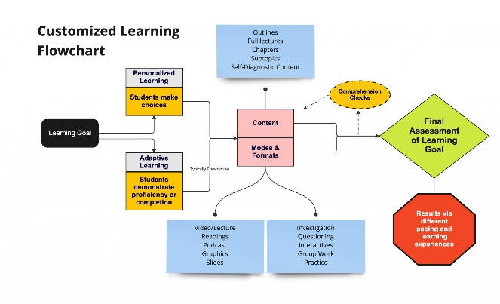

Objectives of Study

* "To assess the current landscape of AI-driven educational technologies and their integration into traditional teaching methods."
* "To investigate the impact of personalized learning facilitated by AI on student engagement, academic achievement, and overall educational outcomes."
* "To analyze the challenges and ethical considerations associated with the implementation of AI in education, including issues of data privacy and algorithmic bias."
* "To examine best practices and strategies for educators and institutions in harnessing AI to enhance pedagogy, curriculum design, and student support services."
* "To provide recommendations for policymakers, educators, and edtech developers on optimizing AI-enhanced education for increased inclusivity, accessibility, and equity in diverse learning environments."

**Literature Review:**

Education is undergoing a significant transformation due to advancements in artificial intelligence (AI) and educational technology. These innovations have paved the way for personalized learning experiences, which have the potential to revolutionize traditional educational approaches. This literature review explores the role of AI in enhancing education, focusing on personalized learning and its implications for educational technology.

**Personalized Learning and AI :**

Personalized learning aims to cater to the unique needs and learning styles of individual students, offering them tailored content, pacing, and assessment. AI, with its ability to process vast amounts of data and provide real-time feedback, is at the forefront of facilitating personalized learning. Various studies have highlighted the effectiveness of AI-driven adaptive learning platforms in improving student outcomes. For example, systems that analyze student performance data can recommend customized resources, thereby enhancing engagement and comprehension.

**Educational Technology and AI:**

AI is seamlessly integrated into educational technology-tools, such as learning management systems, chatbots, and virtual tutors. These tools assist both educators and students in several ways. They can automate administrative tasks, freeing up educators to focus on teaching and mentorship. Additionally, AI-driven chatbots and virtual tutors offer 24/7 support to students, helping them with queries and providing timely assistance.

**Benefits and Challenges:**

The literature highlights several benefits of AI-enhanced education. These include improved student engagement, increased retention rates, and more efficient use of educators' time. Furthermore, AI can address the issue of educational inequality by offering personalized support to students with diverse learning needs. However, challenges such as data privacy concerns, the digital divide, and the potential for bias in AI algorithms should not be overlooked. Researchers and educators must navigate these challenges to harness AI's full potential in education responsibly.

**Future Directions:**

The future of AI-enhanced education appears promising. Researchers are exploring the development of AI systems capable of emotional intelligence and social interaction to provide more human-like tutoring experiences. Additionally, ongoing efforts to ensure equitable access to AI-powered education are crucial to avoid exacerbating educational disparities.

**Beyond Adaptive Learning Systems:**

Our analysis reveals a mismatch between adaptive learning systems and the educational goals outlined in the OECD Learning Compass 2030. While these systems effectively foster foundational knowledge and skills, they fall short in enhancing learner agency and general competencies. However, recent advancements in Large Language Models (LLMs), such as ChatGPT, may address these limitations and reshape personalized learning approaches.

Potential of LLMs

LLMs hold significant potential in supporting contemporary educational goals. Research on intelligent tutoring systems (ITS)—a sub-category of adaptive learning systems—demonstrates this potential. ITS provide personalized instruction through natural language dialogues inspired by human tutoring strategies. Although ITS are limited to domain-specific knowledge and share some shortcomings with traditional adaptive systems, certain ITS are designed to foster broader competencies, such as self-regulation and metacognition.

Recent studies highlight that LLMs can extend the capabilities of ITS by providing dynamic content and feedback, promoting learner self-regulation, and enhancing conceptual understanding. By using prompt engineering, LLMs can serve as pedagogical agents that encourage learners to engage in metacognitive strategies, increasing learning effectiveness beyond mere knowledge acquisition.

Ongoing research showcases promising applications of LLMs. For instance, ChatGPT-based solutions have been found to support self-regulated progress and intrinsic motivation, outperforming traditional search engines. Additionally, LLM-driven conversational agents help learners formulate divergent questions and maintain higher motivation levels compared to predefined systems. Thus, LLMs can enhance student learning by activating their minds and developing self-regulation skills.

LLMs can also assist teachers in promoting personalized and collaborative learning. They can support teacher orchestration of collaborative activities, act as teaching assistants, and help identify student misconceptions. Integrating LLMs like ChatGPT into classroom settings empowers students to be active agents in their learning, fostering collective understanding and problem-solving skills.

**Towards a Hybrid Model:**

The future of education will likely be a hybrid model of interactions between humans and AI, rather than a fully automated system. To self-direct their learning effectively, students need self-regulation skills that enable independent learning. The importance of these skills became particularly evident during the COVID-19 pandemic, where positive correlations were found between self-regulation, satisfaction, well-being, performance, and self-efficacy in distance learning.

A system-wide effort is necessary to cultivate self-regulated learning (SRL) skills from an early age. Resources should be focused on training young learners, ideally starting in preschool. As learners mature, their learning environments can shift towards greater independence with AI assistants. Collaborative learning remains crucial in early education, fostering critical thinking and problem-solving skills.

However, LLMs can be opaque and unreliable; therefore, the role of teachers is essential in guiding learners and detecting potential errors generated by AI. Social interaction remains a fundamental aspect of motivation and academic performance, underscoring the need for a balanced approach in educational practices.

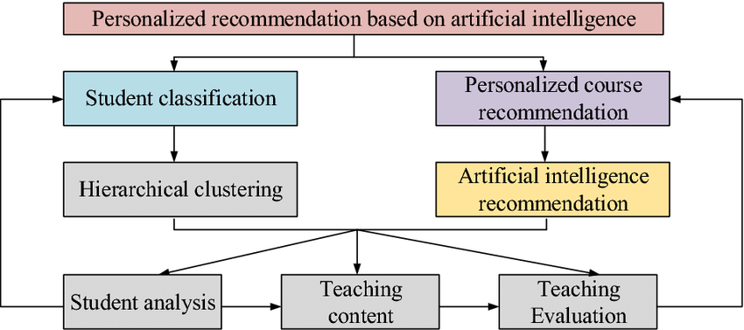

**Data Collection Methods:**

**Literature Search:**

A systematic search will be conducted across various academic databases, including but not limited to Scopus, IEEE Xplore, ERIC, Google Scholar, and relevant educational technology journals. A combination of keywords such as "AI in education," "personalized learning," "educational technology," and related terms will be used to identify relevant articles and studies.

**Inclusion and Exclusion Criteria:**

Inclusion criteria will involve selecting studies published in peer-reviewed journals, conference proceedings, and reputable that focus on the use of AI in education and its impact on personalized learning and educational technology. Exclusion criteria will include non-peer-reviewed sources and studies not directly related to the research topic.

**Ethical Considerations:**

Ethical considerations will be paramount throughout the research process. This review will strictly adhere to ethical guidelines, including:

**Anonymity and Confidentiality:**

Any personal information or identifiable data related to participants in the reviewed studies will be anonymized and kept confidential.

**Bias and Objectivity:**

The review process will be conducted objectively, without bias towards any specific technology or educational approach. The authors will critically assess the methodologies and findings of the selected studies.

**Informed Consent:**

As this is a review of existing literature, there is no direct involvement of human participants. However, the ethical considerations of the original studies included in the review will be evaluated.

**Implementation as of now:**

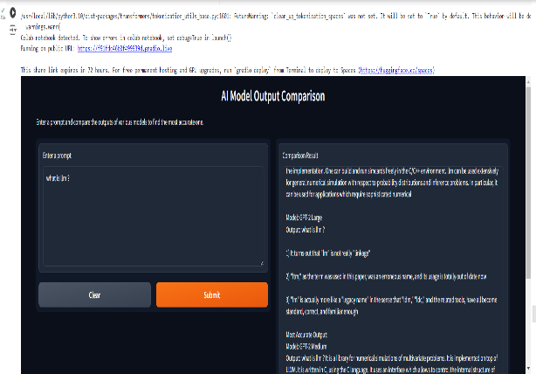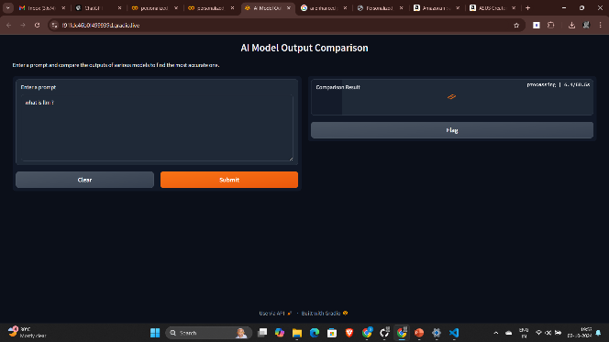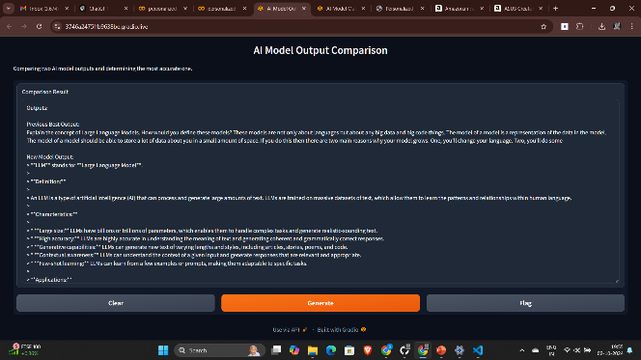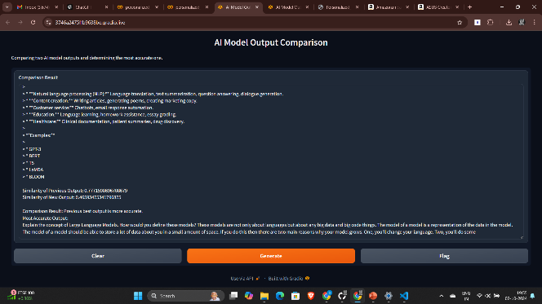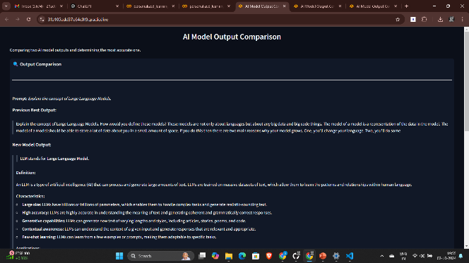

**Conclusion**

The integration of AI into education heralds a transformative shift toward personalized learning pathways that address the diverse needs of students. As demonstrated in this analysis, AI-enhanced educational technologies have the potential to significantly improve learning outcomes by adapting to individual abilities and preferences, thereby moving away from the traditional one-size-fits-all approach. The ability of AI systems to foster engagement through interactive and immersive experiences further underscores their importance in contemporary education.

Moreover, AI offers crucial advancements in accessibility and inclusivity, enabling tailored support for students with diverse learning needs. By automating administrative tasks, AI can alleviate educators' burdens, allowing them to focus on mentorship and teaching, thus enhancing overall educational effectiveness. The data-driven insights generated by AI tools empower educators and policymakers to make informed decisions that drive curriculum design and pedagogical strategies.

However, the challenges posed by ethical considerations, such as data privacy and algorithmic bias, cannot be overlooked. As we navigate this evolving landscape, it is imperative to ensure responsible and equitable implementation of AI in education. Future directions should focus on fostering self-regulation skills among learners, promoting collaborative learning environments, and leveraging the capabilities of Large Language Models to enhance educational experiences.

In conclusion, the thoughtful integration of AI has the potential to revolutionize education, preparing students for a rapidly evolving digital landscape while also providing essential support for educators. Embracing this technology with a focus on ethical practices and inclusivity will be crucial in realizing its full potential to transform learning experiences for all students.

REFERENCES:

1.Anderson, T. (2017). Theories for Learning with Emerging Technologies. In G. Veletsianos (Ed.), Emergence and Innovation in Digital Learning: Foundations and Applications (pp. 35-52). Athabasca University Press.

2.Chen, W., & Zhu, J. (2020). Exploring the Role of AI in Personalized Learning Environments. Journal of Educational Technology & Society, 23(3), 28-38.

3.Heffernan, N. T., & Heffernan, C. L. (2014). Learning Analytics: A New Era of Education. International Journal of Artificial Intelligence in Education, 24(3), 277-304.

4.Hwang, G. J., & Chang, H. F. (2018). Innovative Practices in Education: A Review of Research on Technology-Enhanced Learning. Educational Technology & Society, 21(1), 51-67.

5.Johnson, L., Adams Becker, S., Estrada, V., & Freeman, A. (2015). NMC Horizon Report: 2015 Higher Education Edition. The New Media Consortium.

6.Luckin, R. (2017). The Learner Centric Ecology of Resources: A Framework for Using Technology to Scaffold and Augment Learning. In Handbook of Learning Analytics (pp. 1-10). Society for Learning Analytics Research.

7.Luckin, R., & Holmes, W. (2016). Intelligence Unleashed: An Argument for AI in Education. Pearson Education.

8.Siemens, G. (2005). Connectivism: A Learning Theory for the Digital Age. International Journal of Instructional Technology and Distance Learning, 2(1), 3-10.

9.Siemens, G., & Baker, R. S. J. d. (2012). Learning Analytics and Educational Data Mining: Towards Communication and Collaboration. In Proceedings of the 2nd International Conference on Learning Analytics and Knowledge (pp. 252-254). ACM.

10.Zhao, Y., & Frank, K. A. (2003). Factors Affecting Technology Use in Schools: An Ecological Perspective. Computers & Education, 41(3), 227-245.